# ****Phase 5: Apex Programming (Developer)****

**Project:** Smart Healthcare Appointment & Patient Management System  
**Prepared by:** Kakumani Naga Jahnavi

## ****Objective****

Phase 5 focuses on implementing custom business logic using Apex to automate critical healthcare processes such as appointment status updates, insurance claim handling, reminders, and reporting. The objective is to enhance the efficiency, accuracy, and scalability of the hospital CRM, ensuring that routine administrative tasks are handled automatically, and staff can focus on patient care.

## ****Apex Triggers****

Apex triggers are used to automatically update appointment or claim records based on specific events within the CRM. For example, the system can update an appointment status to “Completed” once the consultation ends or notify insurance officers when a claim is submitted. Triggers ensure real-time updates, reduce manual errors, and maintain consistent record status across the system, which is critical in a healthcare environment where timely information is essential.

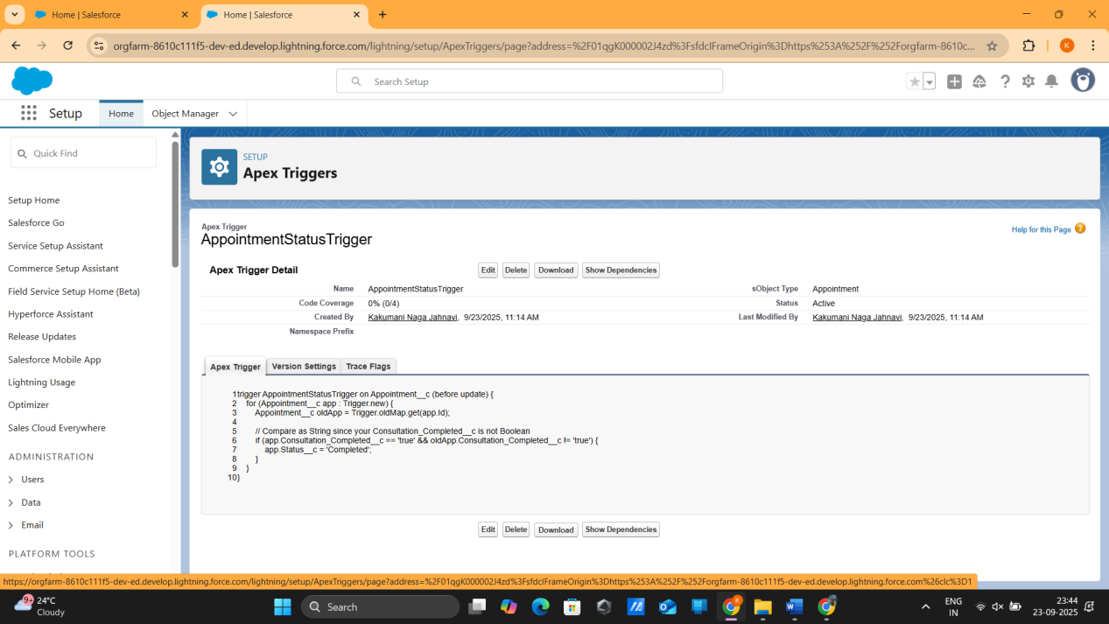

## ****SOQL Queries****

SOQL queries are employed to efficiently retrieve records from Salesforce objects for processing within Apex logic. In this phase, queries are used to fetch all pending insurance claims or retrieve appointments scheduled for specific date ranges. By selecting only the necessary fields and records, SOQL queries improve system performance and support automation in triggers, batch Apex, and queueable Apex processes.

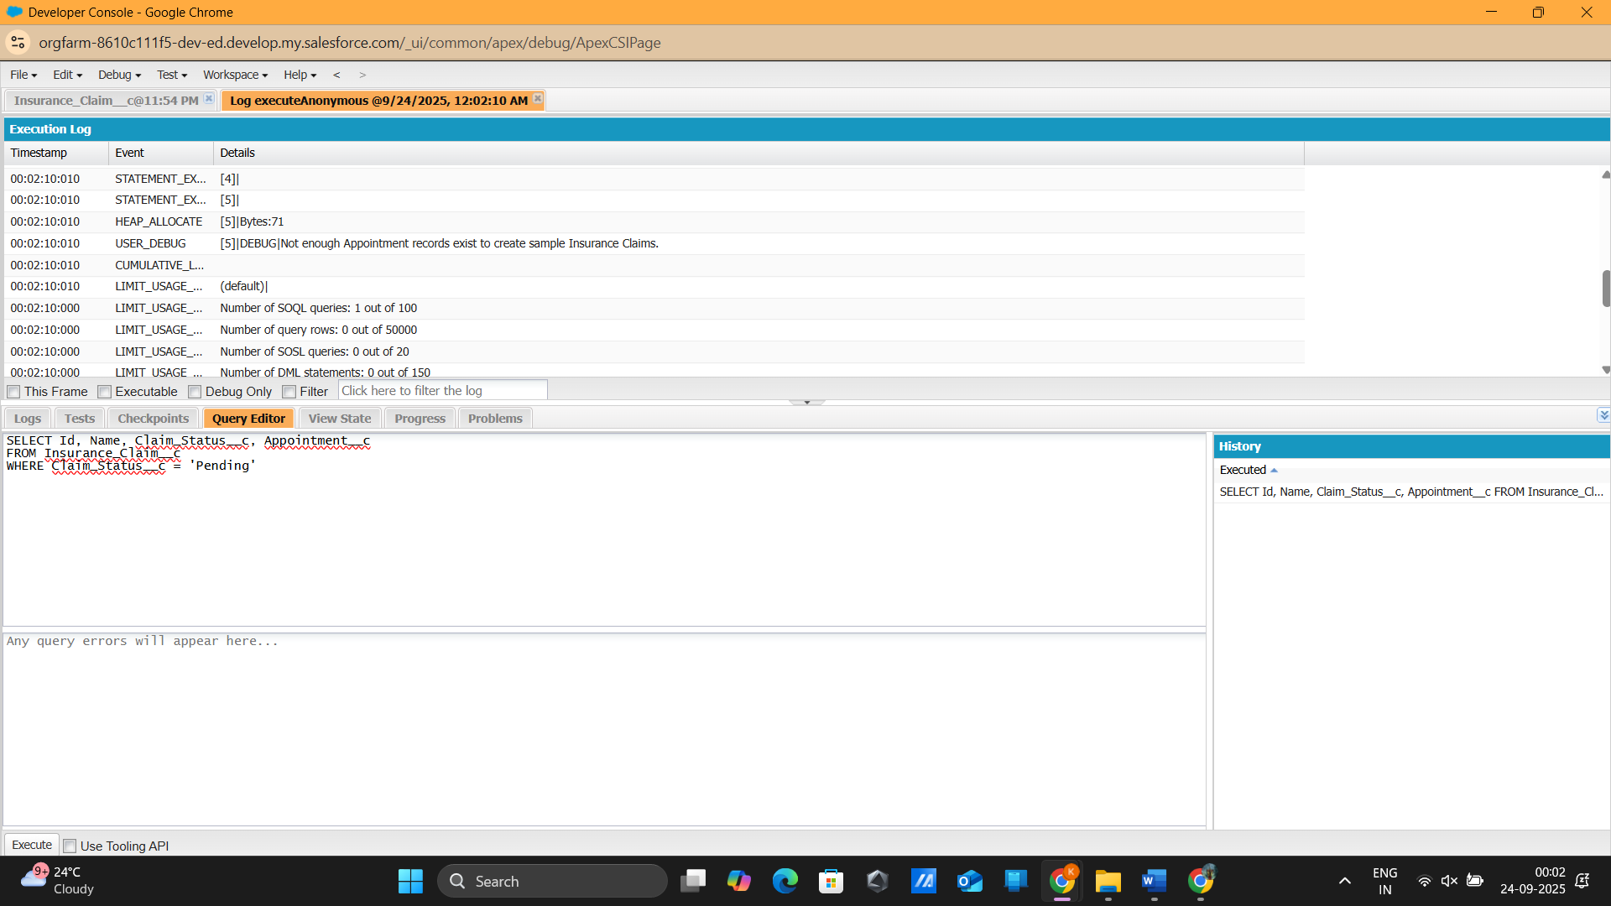

## ****Batch Apex****

Batch Apex allows the system to process large volumes of records asynchronously in batches, preventing governor limit violations. In this project, batch Apex is used to send weekly summary emails of appointments to hospital administrators. It enables bulk processing of records without impacting system performance and automates periodic reporting tasks, ensuring administrators have timely insights into hospital operations.

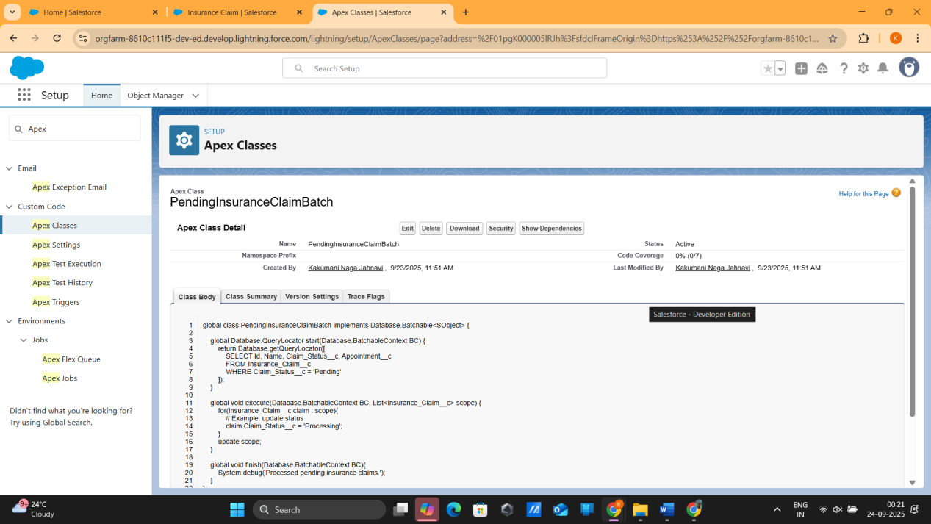

## ****Queueable Apex****

Queueable Apex is used to handle asynchronous bulk processing tasks with greater flexibility than traditional batch jobs. In the context of the Smart Healthcare CRM, queueable Apex is employed to update the status of multiple pending insurance claims and to chain dependent jobs for sequential processing. This approach allows for scalable asynchronous operations, which is essential for handling fluctuating workloads in healthcare administration.

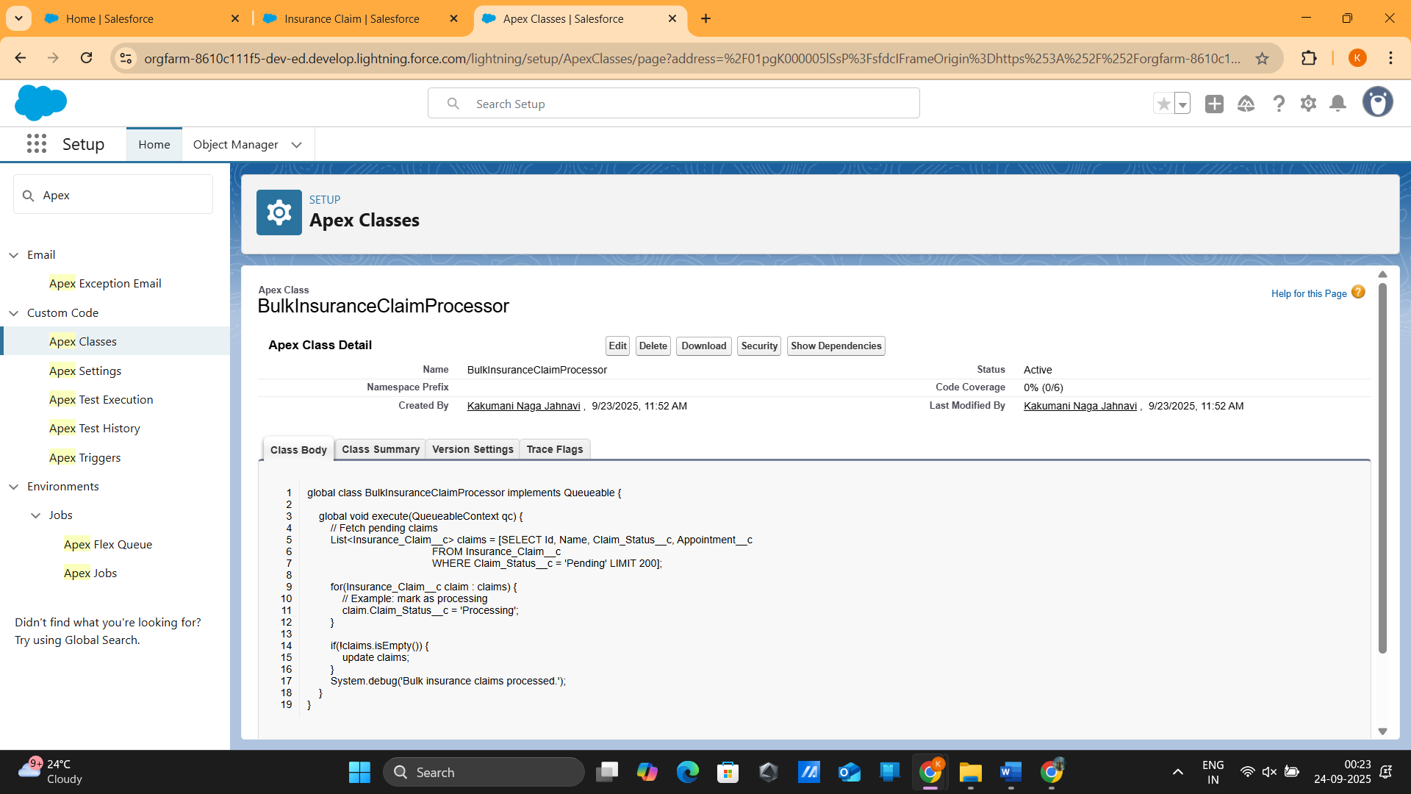

## ****Scheduled Apex****

Scheduled Apex automates recurring tasks to run at defined intervals without manual intervention. In this phase, it is used to send daily reports of upcoming appointments to hospital administrators. Scheduled Apex ensures that reporting and notifications occur consistently, reducing the reliance on manual processes and enhancing operational efficiency by delivering timely information to stakeholders.

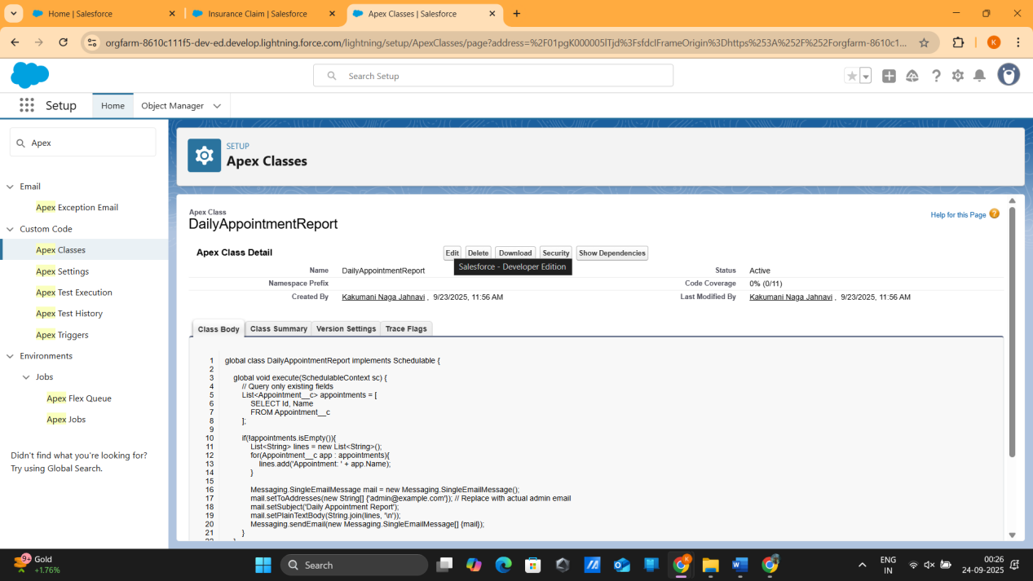

## ****Future Methods****

Future methods provide a mechanism to perform asynchronous callouts or long-running tasks without blocking the main execution thread. In the Smart Healthcare CRM, future methods are utilized to send SMS reminders to patients before their scheduled appointments. This improves patient engagement, reduces no-shows, and integrates seamlessly with third-party notification services without impacting system performance.

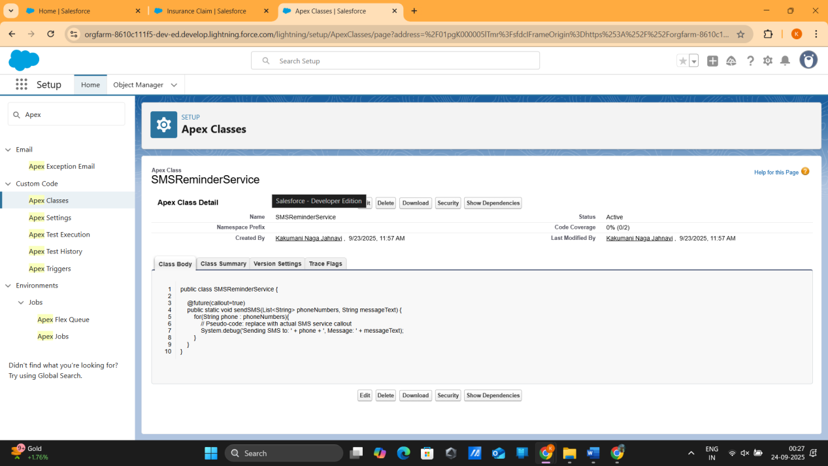

## ****Test Classes****

Test classes are developed to validate all Apex logic including triggers, batch jobs, queueable jobs, and future methods. They ensure that business rules function correctly, meet Salesforce deployment requirements, and achieve the required code coverage of at least 75 percent. Test classes are essential for maintaining system reliability, preventing errors during deployment, and ensuring data integrity within the healthcare CRM.

